**INTRODUCTION**

Understanding the problem in the existing system & finding requested solution is the most important activity while planning the project. Hence the developing a new system we must get through problem associated with the current system.

The project Hospital Management System is aimed to develop to maintain the day to day state of admission / discharge of the patient, list of doctors, list of medicines an bill etc.

* Using this software all the records of admission / discharge of patients are maintained directly in database and no need to maintain them in registers which will reduce the amount of time required for this.
* Hospital facilities need consistent maintenance management and persistent control of the utility of hospital assets and equipments to maintain a clean and healthy environment.
* All the records of medical equipment and tools would be handled using this software.
* All the calculation part would be handled using this software which were done manully.
* The reports can be generated to view the data such as billing information, etc. Hence the user can view data through reports.
* The data is stored in a single database providing real time data across applications throughout the hospital. This encompasses human (and paper-based) information processing as well as data processing machines.

**LIMITATIONS OF THE EXISTING SYSTEM**

* Keeping all the records of the admission and discharge of the patient manually in registers is not the feasible way, it is time consuming process and many people have to involve in the same process.
* Keeping records of medicine department, surgical equipment and tools and laboratory tools are also lengthy and time consuming process.
* Keeping explicit details about the patient’s disease, diagnosis and management of comprehensive research.

**PROPOSED SYSTEM**

* This system helps to maintain the records of medicines, various exams, doctor details, etc.
* It also helps to add new patient details, their medical details; exams conducted, discharge details, etc.
* It maintains bill payment details of patients and generates the bill reports in crystal report format.
* The tools like calculator and notepad are provided to calculate bill amounts, discounts etc.

**HARDWARE REQUIREMENT**

Computer are never fast enough and rarely have enough space or Memory, so as the faster and more powerful your computer is better as suggest that an ideal system for a professional

Intel Pentium P4

256 MB of memory

15” screen

1.00 GB of disk space

Realistically though, software be run with more modest configuration and still provide reasonably performance. The minimum that you need so that the performance adequate is

* Intel 80486x4 or better
* 16 MB or more of memory
* 15” screen
* 1 GB of disk space for a full flow work

And the components that are not variable are:

* Keyboard (84 keys or more)
* Mouse (any standard)
* Printer (to print reports)

System Software Requirements:-

* Operating System : Windows Operating System
* Front End: : Vb.NET
* Back End: : MS SQL server 2005

**DATA DICTIONARY**

Table Name: INPATIENTS

Description: This table stores the details about the patients.

|  |  |  |
| --- | --- | --- |
| Fields | Data Type | Description |
| PCODE | int | It stores the unique patient code |
| DOA | varchar(50) | It stores admission date |
| PNAME | nvarchar(50) | It stores the patient name |
| ADDRESS | nvarchar(50) | It stores the patient’s address |
| DOB | Datetime | It stores the birth date of patient |
| AGE | Int | It stores the age |
| CASTE | nvarchar(50) | It stores the caste |
| SEX | nvarchar(50) | It stores the gender |
| BLOODGROUP | nvarchar(50) | Stores the blood group |
| TELNO | int | Stores telephone number |
| MARITALSTATUS | nvarchar(50) | Stores marital status of the patient |
| DOCCODE | int | Stores the doctor code |
| DOCEXAMINED | nvarchar(50) | Stores the name of the doctor examined |
| WARDJOINED | nvarchar(50) | Stores the ward name joined by the patient |
| ROOMTYPE | nvarchar(50) | Stores the type of the room |
| BEDNO | int | Stores the bed number |
| ROOMRENT | varchar(50) | Stores the room rent |
| DIAGNOSIS | nvarchar(50) | Stores the diagnosis done |
| MEDICINEGIVEN | nvarchar(50) | Stores the given medicine names |
| ANESTYPE | nvarchar(50) | Stores the anesthesia type |
| LABOURROOM | nvarchar(50) | Stores labour room number |
| LABOURCASE | nvarchar(50) | Stores labour case number |
| SURGERYTYPE | nvarchar(50) | Stores the type of surgery |
| Billstatus | varchar(50) | Stores bill status paid or unpaid |
| TREATMENT_DATE | datetime | Stores treatment date |

Table Name: IPMEDICINE

Description: This table stores the details about the medicines given to the patient.

|  |  |  |
| --- | --- | --- |
| Fields | Data Type | Description |
| PCODE | int | It stores patient code |
| NAME | nvarchar(50) | It stores patient name |
| MEDICINENAME | nvarchar(50) | It stores medicine name |
| MEDICINETYPE | nvarchar(50) | It stores thetype of the medicine |
| DATEOFISSUE | nvarchar(50) | It stores the issue date |
| QUANTITY | int | It stores the quantity of medicines given |
| RATEPERUNIT | varchar(50) | It stores the rate of medicines per unit |
| AMOUNT | varchar(50) | It stores the amount of medicines |
| DISCOUNTGIVEN | varchar(50) | It stores the discount given to patient |
| TOTALAMOUNT | varchar(50) | It stores the total amount of medicines |

Table Name: IPEXAMS

Description: This table stores the details about the exams conducted for a ptient.

|  |  |  |
| --- | --- | --- |
| Fields | Data Type | Description |
| EXAMCODE | int | It stores the unique exam code |
| PCODE | int | It stores the patient code |
| NAME | nvarchar(50) | It stores the patient name |
| EXAMTYPE | nvarchar(50) | It stores the type of exam conducted |
| EXAMDATE | datetime | It stores the date of exam conducted |
| EXAMDETAILS | nvarchar(50) | It stores the exam details |
| EXAMCOST | varchar(50) | It stores the exam cost |
| DISCOUNTGIVEN | varchar(50) | It stores the discount given of exam cost |
| TOTALAMOUNT | varchar(50) | It stores the total amount |

Table Name: DISCHARGE

Description: This table stores the discharge details.

|  |  |  |
| --- | --- | --- |
| Fields | Data Type | Description |
| PCODE | int | It stores the patient code |
| PNAME | nvarchar(50) | It stores the patient name |
| DOA | datetime | It stores the date of admission |
| DOD | datetime | It stores the date of discharge |
| DOCNAME | nvarchar(50) | It stores the doctor name |
| ROOMTYPE | nvarchar(50) | It stores the type of the room |
| WARDNAME | nvarchar(50) | It stores the joined ward name |
| BEDNO | int | It stores the bed number |
| ROOMRENT | varchar(50) | It stores the room rent amount |
| DIAGNOSIS | nvarchar(50) | It stores the diagnosis done |
| DAYSINHOS | int | It stores the number of days for which the patient was in hospital |
| TOTALAMT | int | It stores the total amount |

Table Name: Opdet

Description: This table stores the details of the patients that are ready for discharge.

|  |  |  |
| --- | --- | --- |
| Fields | Data Type | Description |
| PCODE | int | It stores the patient code |
| PNAME | varchar(50) | It stores the patient name |
| ADDRESS | varchar(50) | It stores the patient address |
| BDATE | datetime | It stores the birth date of patient |
| CASTE | varchar(50) | It stores the caste of patient |
| GENDER | varchar(50) | It stores the gender of patient |
| AGE | int | It stores the age of patient |
| TELNO | varchar(50) | It stores the patient’s telephone number |
| MARSTAT | varchar(50) | It stores the marital status of patient |
| BGRP | varchar(50) | It stores the blood group of patient |
| DOCCODE | varchar(50) | It stores the doctor code |
| DOCNAME | varchar(50) | It stores the doctor name |
| DIAGNOSIS | varchar(50) | It stores the diagnosis done |
| TRETMNTDT | datetime | It stores the treatment date |

Table Name: MEDICINE

Description: This table stores the details of the medicines available in hospital.

|  |  |  |
| --- | --- | --- |
| Fields | Data Type | Description |
| MEDID | int | It stores the unique id of medicines |
| MEDICINENAME | nvarchar(31) | It stores the name of medicines |

Table Name: LABEXAMS

Description: This table stores the details of the exams conducted in the hospital.

|  |  |  |
| --- | --- | --- |
| Fields | Data Type | Description |
| LABEXMID | int | It stores the exam code |
| EXAMNAME | nvarchar(50) | It stores the exam name |

Table Name: DOCTORS

Description: This table stores the details of the doctors from the hospital.

|  |  |  |
| --- | --- | --- |
| Fields | Data Type | Description |
| CODE | int | It stores the unique doctor code |
| DOCNAME | nvarchar(50) | It stores the doctor name |
| MARISTAT | nvarchar(50) | It stores the marital status |
| SPCLZATION | nvarchar(50) | It stores the specialization done by the doctor |
| ADDRESS | nvarchar(50) | It stores the address of the doctor |
| NATURE | nvarchar(50) | It stores the nature of the doctor |
| QUALIFICATION | nvarchar(50) | It stores the qualification of the doctor |

Table Name: BillPayments

Description: This table stores the details of the bill payments of the patient.

|  |  |  |
| --- | --- | --- |
| Fields | Data Type | Description |
| PCODE | int | It stores the unique patient code |
| BillPaymentId | int | It stores the unique bill payment id |
| BillId | float | It stores the unique bill id |
| AmountPaid | float | It stores the amount paid |
| PaidDate | datetime | It stores the payment date |
| PayType | nvarchar(8) | It stores the type of payment cash or cheque |
| DDNo | nvarchar(30) | It stores the DD number |
| DDDate | datetime | It stores the DD date |
| Bank | nvarchar(20) | It stores the bank name |

**E-R Diagram:-**

IPMEDICINE

INPATIENT

Maintains

Maintains

DISCHARGE

Hospital Management System

IPEXAMS

Generates

BILL

Maintains

OPDET

Doctor

**Context Level Diagram:-**

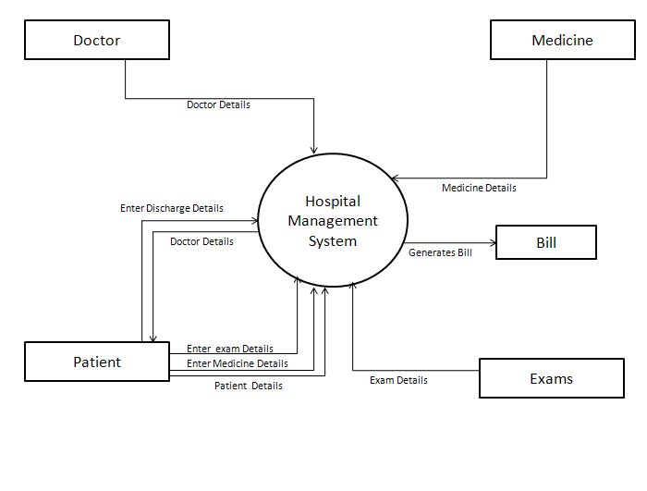

**Data Flow Diagrams:-**

Exam

3.1

Exam Details

Exam

Medicine

2.1

Medicine Details

Medicine

Doctor

1.1

Doctor Details

Doctor

4.2

Exam

Details

Medicine

Exam

Patient

4.3

Medicine

Details

Patient

41

Patient Details

**TESTING**

Software testing is a critical element of software quality assurance and represents the ultimate review of specification, design, coding.

**Testing objectives**

1. Testing is a process of executing a program with the intent of finding an error.

2. A good test case is the one that has high portability of finding an as-yet undiscovered error.

3. A successful test is one that uncovers an as-yet discovered error.

The main objective here will be to design test cases to uncover different classes of errors and to do so with minimum amount of time and efforts. If testing is conducted successfully it will uncover errors in the software. Another advantage is that it demonstrates that software functions appear to be working according to the specifications and performance requirement have been met.

But Testing cannot show the absence of defects it can show only that software errors are present.

**Strategies used for software testing**

The software engineering process is viewed as spiral as shown:

**Unit testing** begins at the vortex of the spiral and concentrates at the each unit of the software as implemented in the source code. Unit testing assures each module tested individually functions properly as a unit.

**Integration testing** focuses on the design and construction of the software architecture. It is a systematic technique for constructing a program structure while conducting tests to uncover errors associated with interfacing. The objective is to take unit-tested module and build a program structure that has been specified as design.

**Validation testing** takes care of the requirements established as part of the software requirements analysis are validated against the software that has been constructed. It is said to be successful when the software functions in a manner that can be reasonably expected by the customer.

**System testing** tests software and other system elements as a whole. These tests fall outside the scope of software engineering process and are not conducted solely by the software developer.

**DATA MODULES AND THEIR DESCRIPTION**

**MDI Form:-**

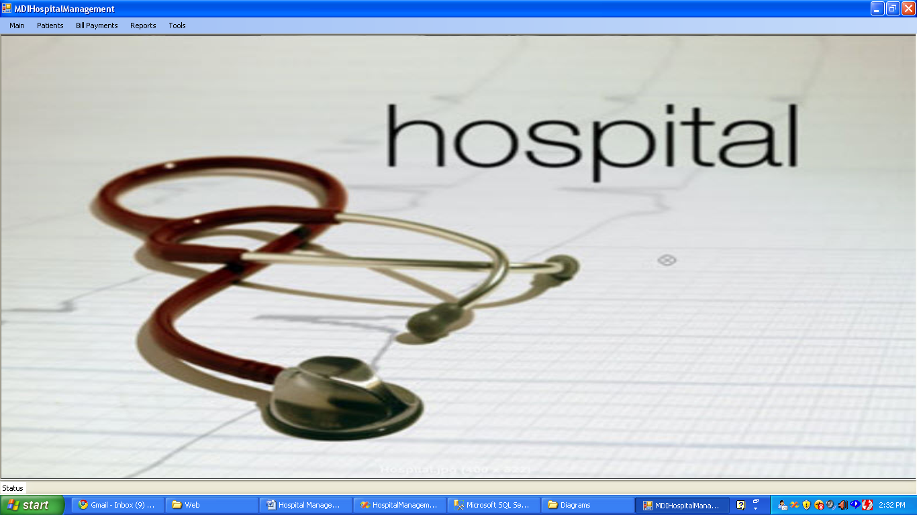

**Medicine:-**

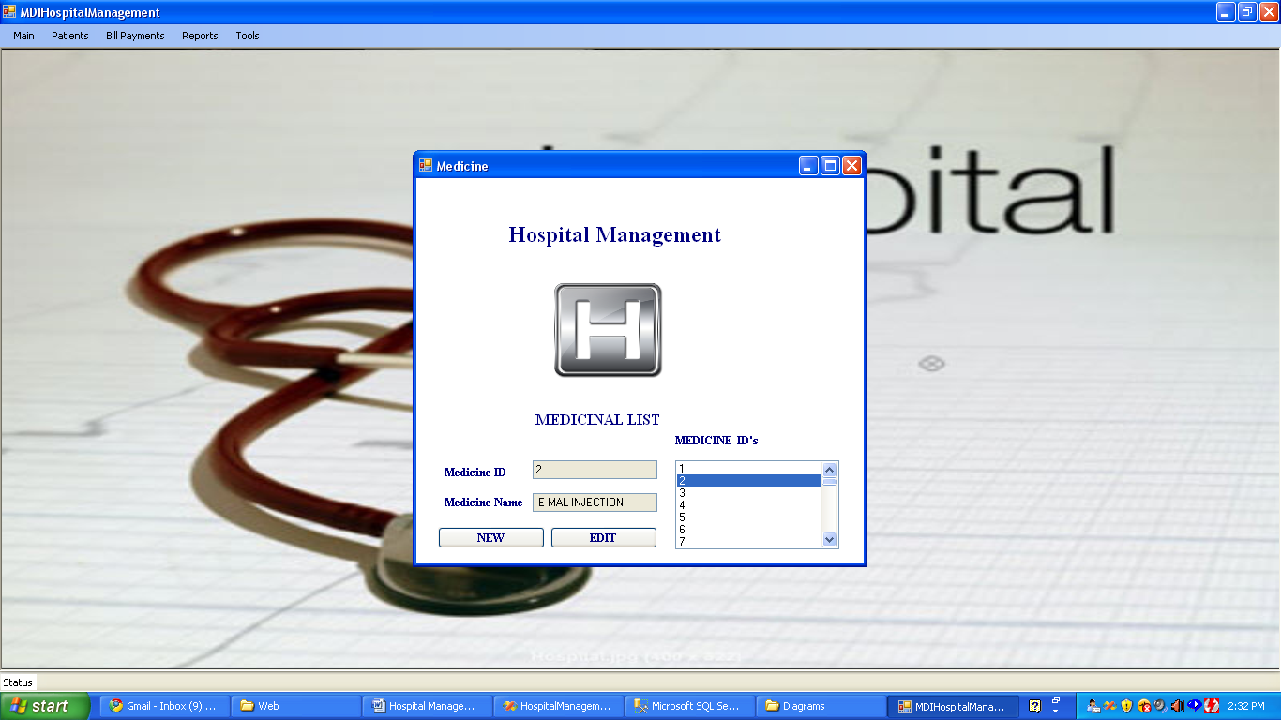

**Lab Test:-**



**Doctor Details:-**

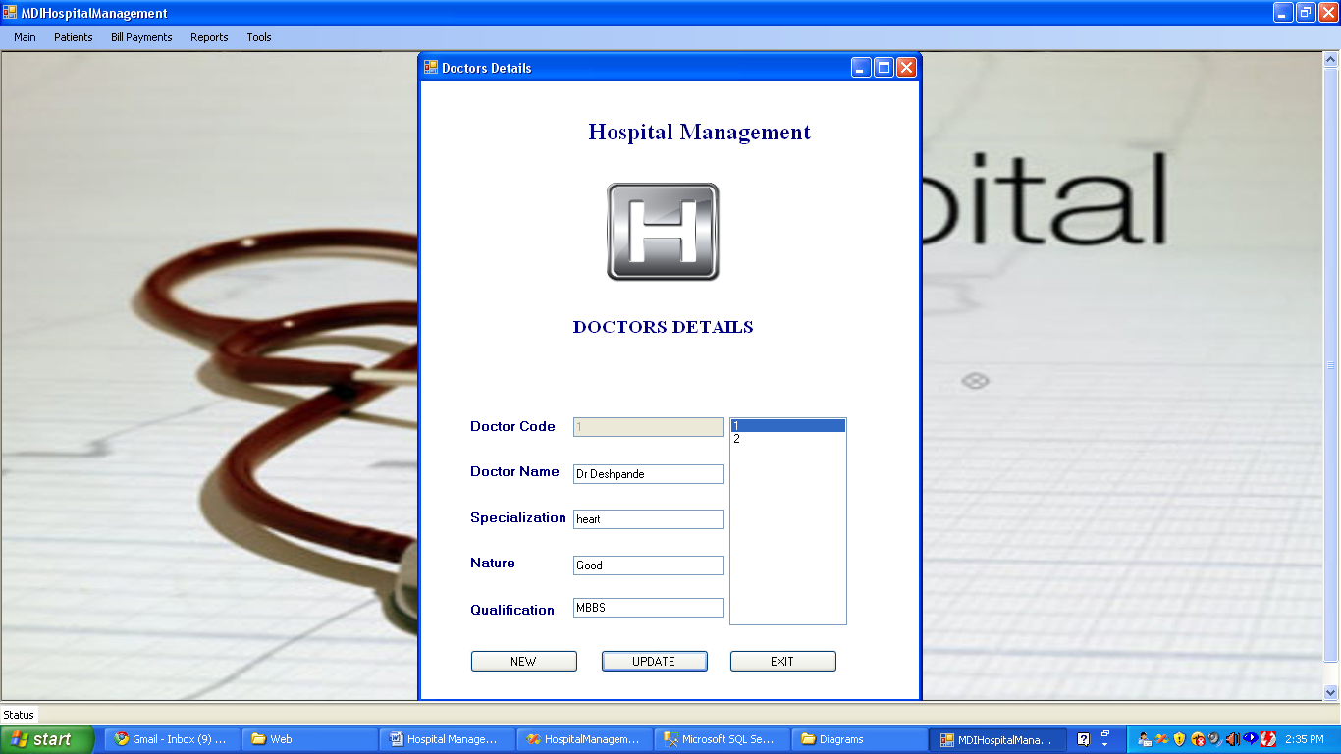

**In Patient Details:-**

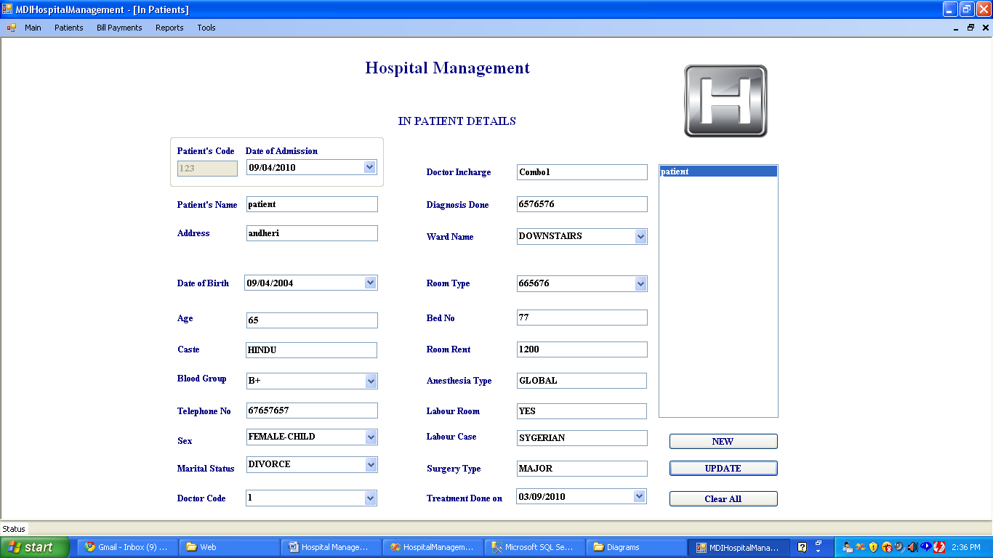

**In Patient Medicine Issues:-**

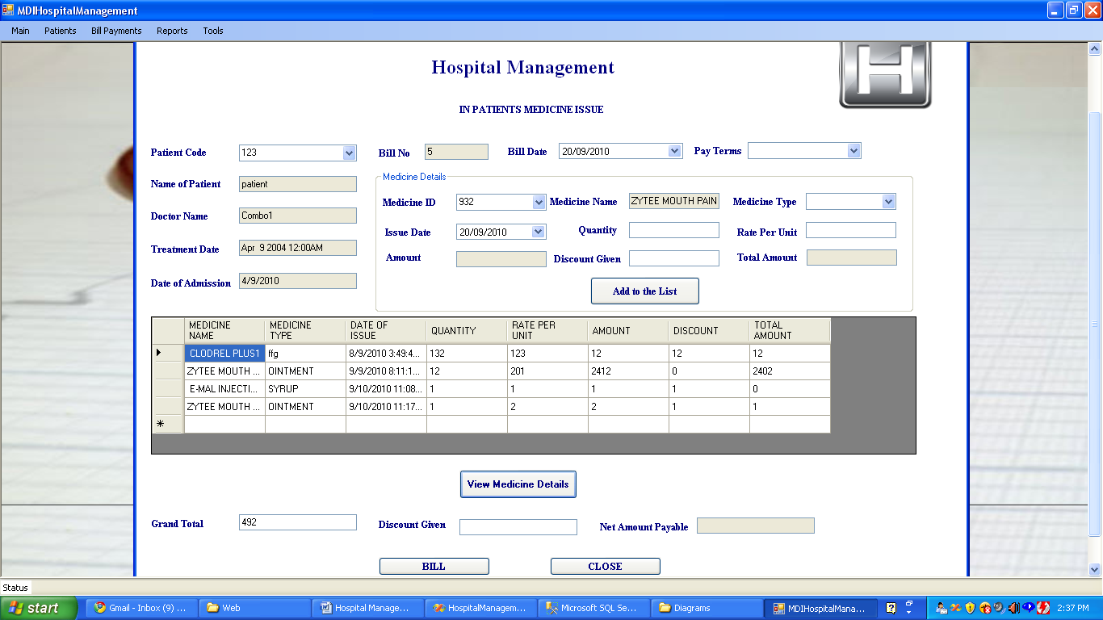

**Reports:-**

**In Patient Bill Report:-**

